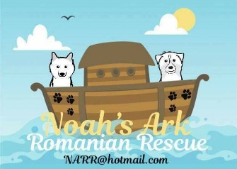
ADOPTION AGREEMENT

NAME:

ADDRESS:

POST CODE:

CONTACT NUMBERS: Mobile: / Landline: / Email:

DOG’S NAME:

DATE OF BIRTH:

MICROCHIP NUMBER:

PASSPORT NUMBER:

NEUTERED: YES / NO

DATE OF ADOPTION:

The above dog(s) has been adopted by:

I fully understand that the above-mentioned dog(s) remains under the ownership of Noah’s Ark Romanian Rescue and, if for any reason I feel the need to rehome the dog, I must inform a member of the Noah’s Ark Romanian Rescue and return the dog to them. I will not sell or give the dog away. I will contact a member of the Noah’s Ark Romanian Rescue team and arrange a suitable day/time to return the dog.

Whilst under my care as adopter, I agree that the dog will be looked after well, fed and watered appropriately and treated with kindness and understanding.

If found for any reason the above terms have not been adhered to, Noah’s Ark Romanian Rescue reserves the right to remove the dog; also if suspected negligence takes place the dog will be removed.

I have read and understood the above and I am happy to adopt the dog mentioned above.

SIGNATURE: _____________________________________ DATE: ___________________________

Noah’s Ark Romanian Rescue contact: Vanda Kizmaz – Mobile: 07778 451528

